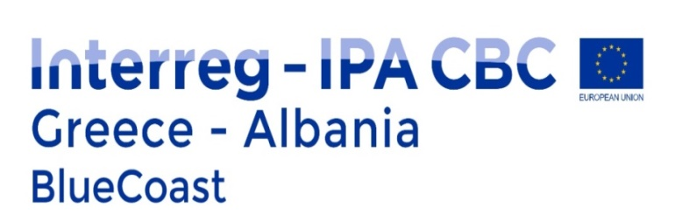

EC DAY GREECE-ALBANIA
PROTECT CARETTA CARETTA, INVEST IN BLUE CULTURE
Saturday 25 September 2021
ZAKYNTHOS
Event Programme

10:30 – 12:30 | ΒΕΑCH CLEANING/ UNDERWATER CLEANING
- Seaside cleaning at the popular beach «Limni Keriou» with the support of Management Agency of Zakynthos National Marine Park, NGO and Civil Society Organisations.
- Loggerhead sea turtle nest public excavation at the «Marathonisi» beach with the support of Management Agency of Zakynthos National Marine Park
18:00 - 21:00 | Actions for the restoration, protection and efficient management of protected Caretta Caretta
- Join us at the central square of Zakynthos to explore the life of Caretta Caretta and find out activities to maintain and protect some of the major habitats in the Mediterranean for the loggerhead sea turtle in the light of climatic change, under the activities of a cross-border cooperation project between Greece and Albania (BlueCoast)
- Enjoy the Photo Exhibition on Climate-Smart Coastal Practices for Blue Governance
- Watch the video installation of sea turtle protection activities implemented via BlueCoast cross border project
- Be amused by the sounds of Zakynthos traditional music
- …. and more!

